 The Skinny Review – December 11th, 2005

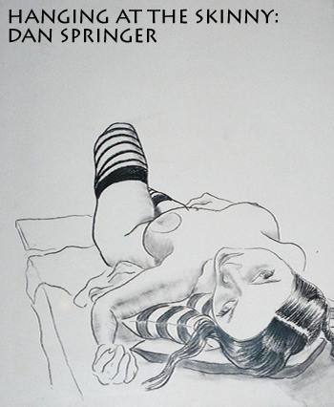
The Skinny, a bar doubling as a gallery on the lower east side, is located in an area that the frou-frou artists of Soho call ‘the grit.’ I suppose there is a distinct rawness to the culture and community in this section of Manhattan. The neighborhood has resisted changing despite the invasion of gentrifying forces. There is a charm to that sort of honesty, which is more than can be said about other neighborhoods that boast of high concentrations of art. This particular evening is the closing party of a show by painter Dan Springer, 36, whose paintings dominate the walls with their quantity, size, and presence. He’s been painting for quite some time now, working in oils since 1985, having used watercolors and acrylics prior to that. He has admitted to being predisposed towards art and painting as a youth; drawing at a very early age and attending the Rhode Island School of Design (RISD).

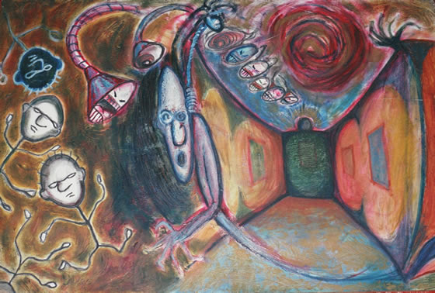
Springer has been showing in a variety of venues including the Ace Gallery in Soho, the Luna lounge – a bar and performance space on the lower east side – and 4E – an apartment turned gallery hosted by Springer and his peers in Tribeca. The gallery, named after their apartment number, promotes a different artist each month in an admirable effort to promote emerging artists. In addition, it displays the hosts’ artwork. Springer has also shown in the clubs Tunnel and Twilo, venues that are unusual choices for a painter.
Hallway
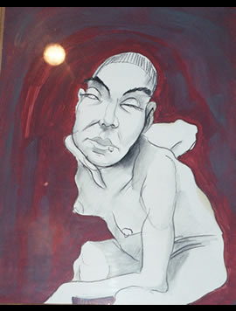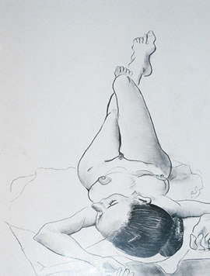
Fly Figure

When probed for the underlying meaning in his pieces, Springer insists that it is the “physiognomy of the face,” or the psychiatry of the subject’s face, that he is attempting to express. Perhaps this explains the extreme nature of his portraits. Springer’s work melds Egon Shiele’s influence with a caricature style. He maintains an identifying detail in each drawing, such as a striped stocking clad calf whose bearer rests in a position that resembles sculpture. Each figure has a dark, thick outline, causing the subjects to pop off the page and exist in a completely different plane than their surroundings. Their backgrounds are painted in solid colors (an old habit of Sheile’s), which offset the black and white shading on the actual figure. They are delicate, morose, and contain an enormous amount of character, especially because each feature is exaggerated to an almost perverse extent. They are comparable to the Tim Burton aesthetic, although Springer’s figures feel more down to earth, more human. This works logistically because his models consequently become close acquaintances.

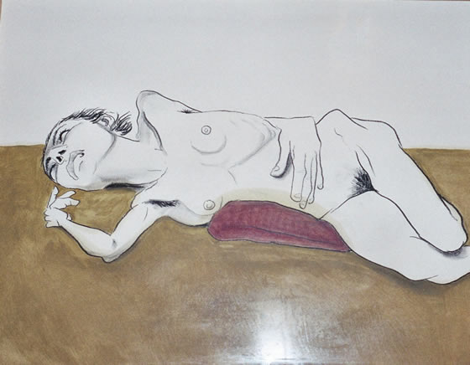
The Skinny
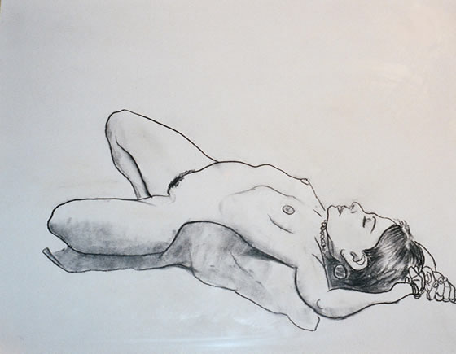
Springer’s paintings of celebrities are a stew of colors. As opposed to the delicate grey shading on his figure drawings, these faces contain an enormous amount of color, pigment, and expression. These faces speak out. They are grandiose in size and could believably smile at you, cry, or give you a raspberry. At first glance they may come off as an excuse for comic relief, but the paintings reveal themselves when due attention is given to the many layers. I am instinctively drawn back to Springer’s original words. His attempt to portray personality and emotion through the face is triumphant.

Sheila

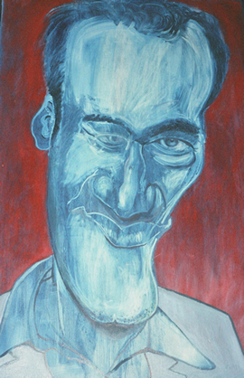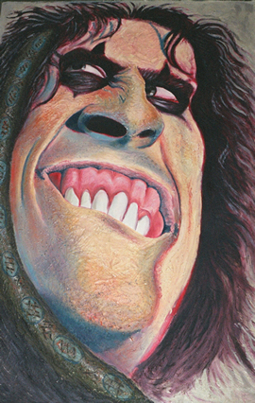
Quentin Tarantino Alice Cooper

